Treasury Report – July 2026
Liquidity, financing and hedging
Jonas Richter · 07 August 2026

Liquidity
Group cash at the end of July amounted to EUR 238.3 m (EUR -13.5 m vs. previous month), of which EUR 40.2 m restricted on Harrow Bay project accounts (debt service reserve and construction accounts). The corporate RCF of EUR 150 m remains undrawn. Liquidity headroom therefore stands at EUR 348.1 m.
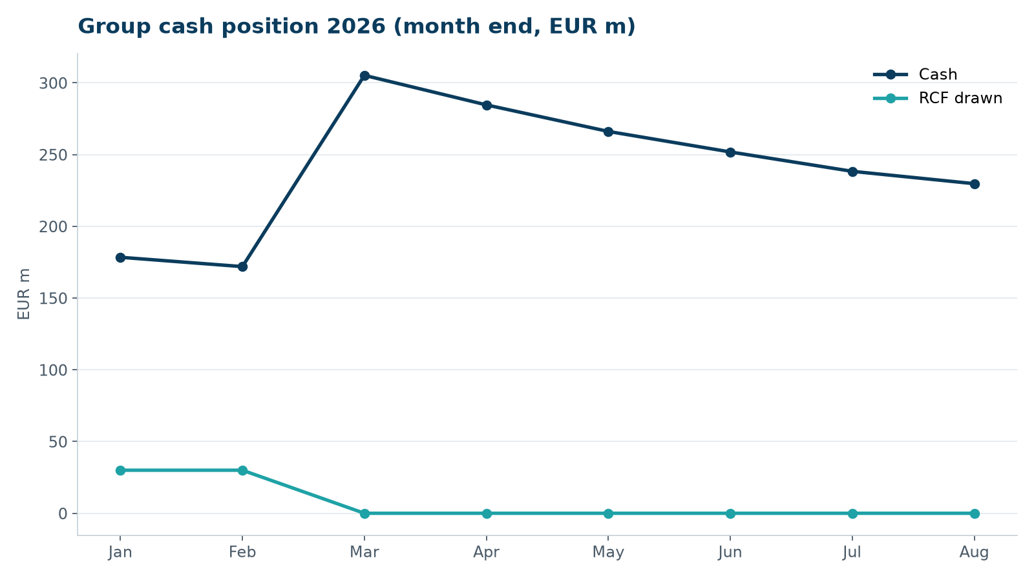
Month-end cash and RCF utilisation 2026

Harrow Bay project finance
Cumulative senior debt drawn under the EUR 1,100 m facility with Hanseatic Infrastructure Bank as agent: EUR 222 m. Drawdown no. 05 of EUR 54 m was funded on 28 July. All conditions precedent were met; the lenders' technical adviser Strandberg Technical Advisory signed off the progress certificate.

Hedging
Instrument | Notional | Rate / level | MtM (EUR m)
Interest rate swaps Harrow Bay (5 banks) | EUR 935 m (amortising) | 2.74 % | +9.4
Interest rate swap Kestrel Ridge | GBP 92 m | 3.12 % | +0.9
FX forwards EUR/GBP (UK cash flows) | GBP 48 m | 0.858 avg. | +0.2
FX forwards EUR/DKK | DKK 120 m | 7.458 | 0.0

Counterparty exposure
Deposits are spread across six banks with a minimum rating of A-. No bank holds more than 30 % of group deposits. The Elbe Commercial Bank deposit was reduced to stay within the 30 % limit.

Covenants
Corporate covenants (net debt / EBITDA ≤ 8.0x, equity ratio ≥ 25 %) are met. Next compliance certificate for the Harrow Bay facility is due on 30 October 2026 for Q3.

